**M.I.T. LAB Assignment – 07**

**U19CS012**

(1) A string of readings is stored in memory, locations starting at 2070H, and the end of the string is indicated by the byte 0DH.

WAP to check each byte in the string, and the save the bytes in the range of 30H to 39H (both inclusive) in memory locations starting from 2090H.

Notepad Code:

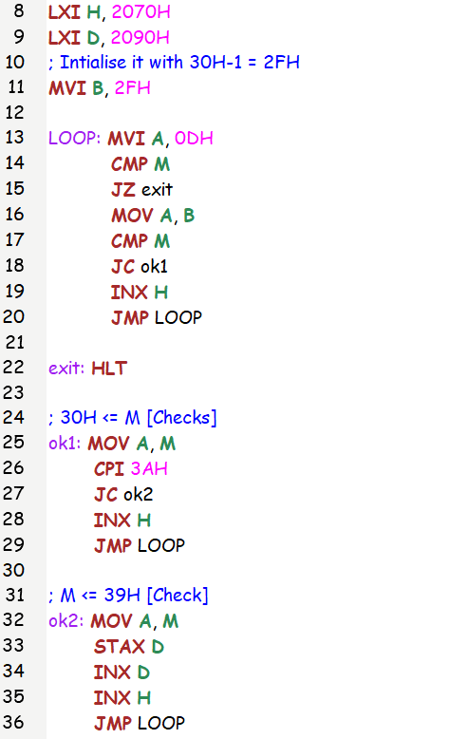

Test Case:

Input : [10, 40, 50, 30, 48, 44, 65, 57, 55, 3, 13]

Output : Numbers 48 <= x <= 57 [50,48,57,55]

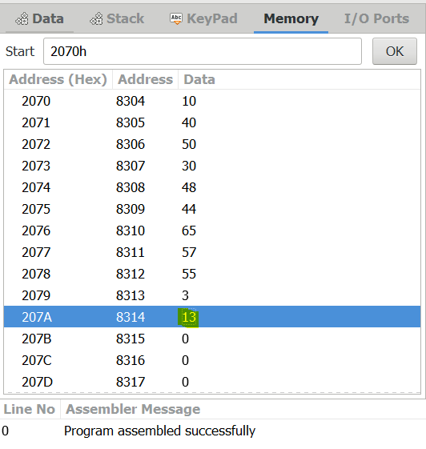 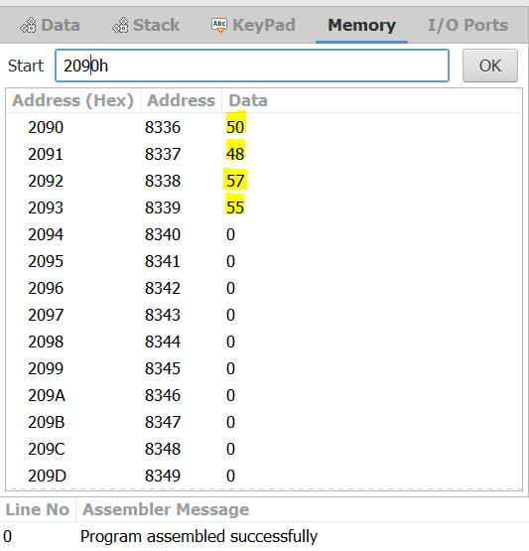

(2) A set of ten bytes is stored in memory starting with the address 2050H.

Write a program to check each byte , and save the bytes that are higher than 6010 and lower than 10010 in memory locations starting from 2060H.

Notepad Code:

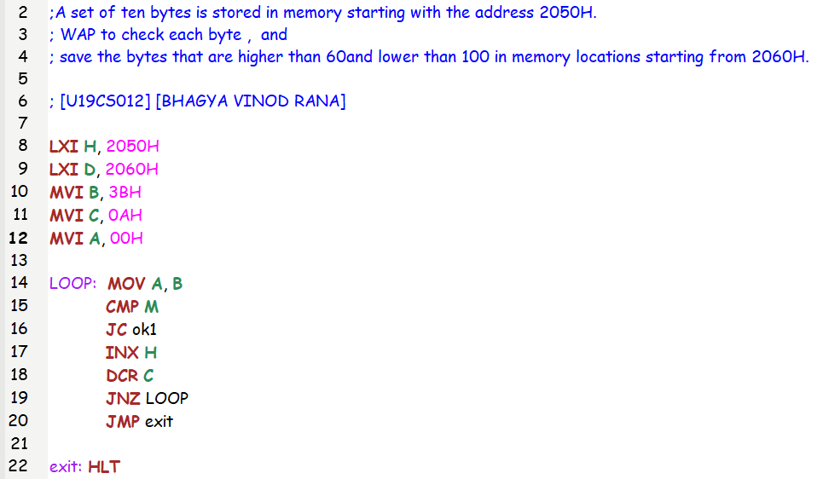

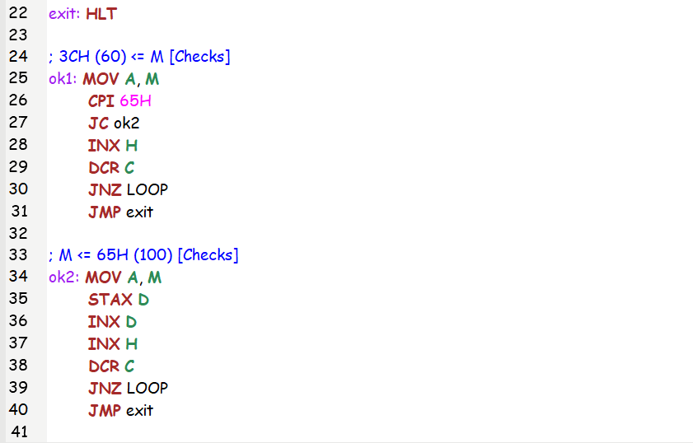

Test Case:

Input : [10, 20, 30, 50, 48, 75, 100, 105, 45, 85, 66]

Output : Numbers 60 <= x <= 100 [75,100,85,66]

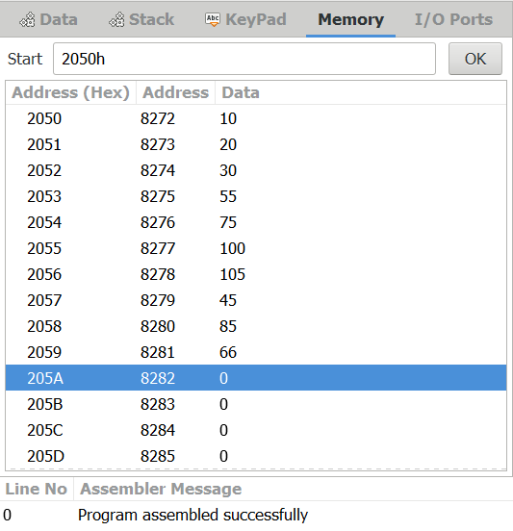 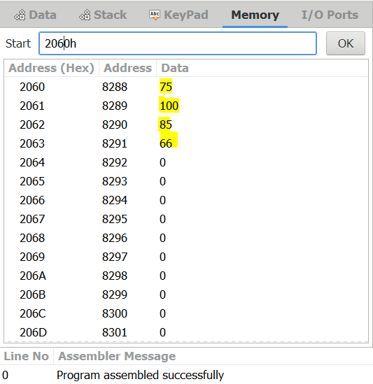

(3) Data bytes are stored in memory locations from 2050H to 205FH.To insert an additional five bytes of data, It is necessary to shift the data string by five memory locations. Write a program to store the data string from 2055H to 2064H.Use any sixteen bytes of data to verify your program.

Notepad Code:

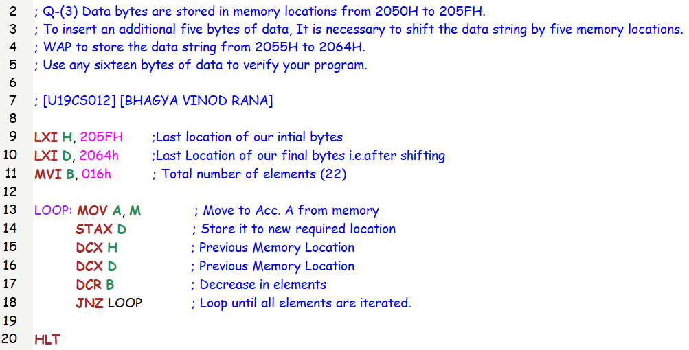

Test Case:

Input : Location **2050H to 205FH** [1,2,3,4,5,6,7,8,9,10,11,12,13,14,15,16]

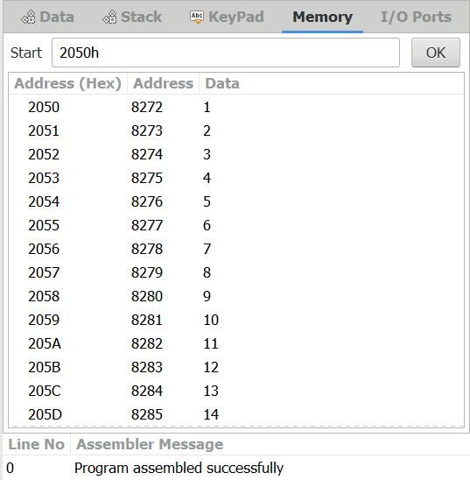 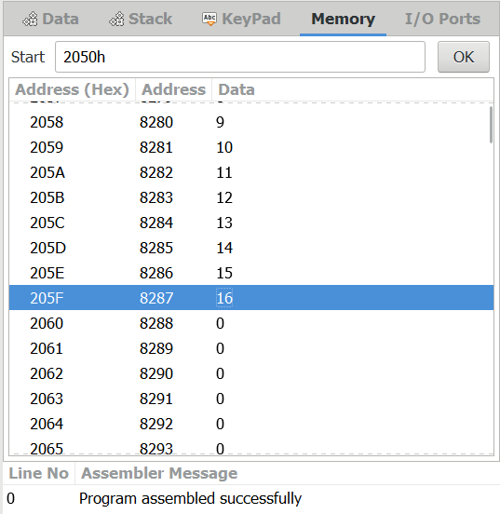

Output :

Location **2055H to 2064H** [1,2,3,4,5,6,7,8,9,10,11,12,13,14,15,16]

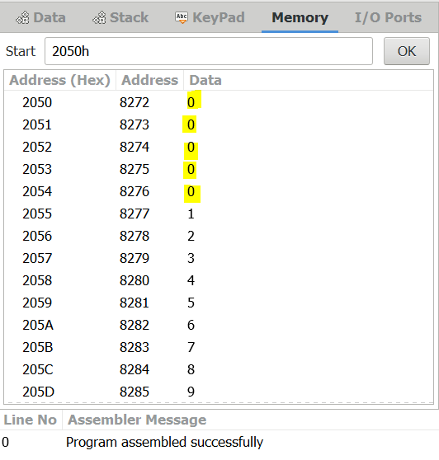 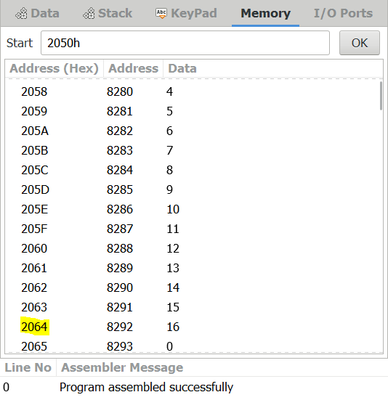

SUBMITTED BY:

BHAGYA VINOD RANA

[***U19CS012***]